WORKSHEET 3 SQL

**Refer the following ERD and answer all the questions in this worksheet. You have to write the queries using mysql for the required Operation.**

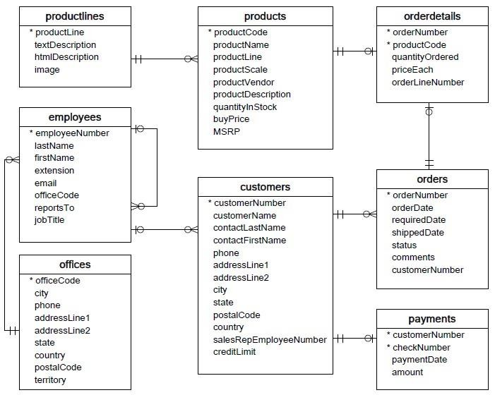

* **Customers**: stores customer’s data.
* **Products**: stores a list of scale model cars.
* **Product Lines**: stores a list of product line categories.
* **Orders**: stores sales orders placed by customers.
* **OrderDetails**: stores sales order line items for each sales order.
* **Payments**: stores payments made by customers based on their accounts.
* **Employees**: stores all employee information as well as the organization structure such as who reports to whom.
* **Offices**: stores sales office data.
  1. Write SQL query to create table **Customers.**
  2. Write SQL query to create table **Orders.**
  3. Write SQL query to show all the columns data from the **Orders** Table.
  4. Write SQL query to show all the comments from the **Orders** Table.
  5. Write a SQL query to show orderDate and Total number of orders placed on that date, from **Orders** table.
  6. Write a SQL query to show employeNumber, lastName, firstName of all the employees from **employees**

table.

* 1. Write a SQL query to show all orderNumber, customerName of the person who placed the respective order.
  2. Write a SQL query to show name of all the customers in one column and salerep employee name in another column.
  3. Write a SQL query to show Date in one column and total payment amount of the payments made on that date from the **payments** table.
  4. Write a SQL query to show all the products productName, MSRP, productDescription from the **products**

table.

* 1. Write a SQL query to print the productName, productDescription of the most ordered product.
  2. Write a SQL query to print the city name where maximum number of orders were placed.
  3. Write a SQL query to get the name of the state having maximum number of customers.
  4. Write a SQL query to print the employee number in one column and Full name of the employee in the second column for all the employees.
  5. Write a SQL query to print the orderNumber, customer Name and total amount paid by the customer for that order (quantityOrdered × priceEach).

Answer :-

1.

mysql> CREATE TABLE Customers (

-> CustomerNumber int NOT NULL,

-> customerName varchar(255),

-> contactLastName varchar(255),

-> contactFirstName varchar(255),

-> Phone int,

-> addressLine1 varchar(255),

-> addressLine2 varchar(255),

-> city varchar(255),

-> state varchar(255),

-> postalcode int,

-> country varchar(255),

-> SalesRepEmployeeNumber int,

-> creditLimit int,

-> PRIMARY KEY (CustomerNumber),

-> FOREIGN KEY (SalesRepEmployeeNumber) REFERENCES employees(employeeNumber)

-> );

2.

mysql> CREATE TABLE Orders (

-> orderNumber int NOT NULL,

-> orderDate date,

-> requiredDate date,

-> shippedDate date,

-> status varchar(255),

-> comments varchar(255),

-> customerNumber int,

-> PRIMARY KEY(orderNumber),

-> FOREIGN KEY (CustomerNumber) REFERENCES Customers(CustomerNumber)

-> );

3.

mysql> select * from Orders;

4.

mysql> select comments from orders;

5.

mysql> SELECT orderDate, count(OrderNumber) as TOTAL_NUMBER_OF_ORDERS FROM Orders GROUP BY orderDate;

6.

mysql> SELECT EmployeeNumber, LastName, FirstName from employees;

7.

mysql> select a.orderNumber, b.customerName from Orders a, Customers b where a.customerNumber=b.CustomerNumber;

8.

mysql> SELECT b.customerName as Customer_Name, RTRIM(LTRIM(CONCAT(COALESCE(a.lastName + ' ', ''), COALESCE(a.firstName + ' ', '')))) AS Sales_Rep_Employee_Name FROM employees a, Customers b where a.employeeNumber=b.SalesRepEmployeeNumber;

9.

mysql> select paymentDate as Date, sum(amount) from payments GROUP BY paymentDate;

10.

mysql> select productName, MSRP, productDescription from products;

11.

mysql> SELECT p.productName, p.productDescription FROM orderdetails AS o INNER JOIN products AS p ON o.productCode = p.productCode GROUP BY o.productCode ORDER BY SUM(o.quantityOdered) DESC, p.productName ASC

12.

mysql> select a.city, count(b.orderNumber) as NUMBER_OF_ORDERS from Customers a, Orders b where a.customerNumber = b.customerNumber GROUP BY a.city ORDER BY NUMBER_OF_ORDERS DESC;

13.

mysql> select state, count(customerNumber) as NUMBER_OF_Customers from Customers GROUP BY state ORDER BY NUMBER_OF_Customers DESC;

14.

mysql> SELECT employeeNumber, RTRIM(LTRIM(CONCAT(COALESCE(lastName + ' ', ''), COALESCE(firstName + ' ', '')))) AS Employee_Full_Name FROM employees;

15.

mysql> select c.orderNumber as ORDER_NUMBER, b.customerName as Customer_Name, c.quantity_ordered*c.priceEach as Total_Amount_Paid from Orders a INNER JOIN Custormers b ON a.customerNumber=b.CustomerNumber INNER JOIN orderdetails c ON a.orderNumber = c.orderNumber GROUP BY c.orderNumber;

